**Unit 2: Rhetorical Analysis through Infographics Assessment Directions**

**Goal:** I can determine the effectiveness of an iconic speech from the 21st century by annotating for DIDLS to determine the tone and then conducting a rhetorical analysis utilizing graphic organizers resulting in an infographic that displays your findings. (W.1, W.4, RI.4, RI.6. RI.9)

Follow the steps below to reach your goal:

1. Research an iconic speech from the 21st Century. It needs to be **a speech from 2007—2017**. Websites to consult are - [**http://www.americanrhetoric.com/21stcenturyspeeches.htm**](http://www.americanrhetoric.com/21stcenturyspeeches.htm)**, http://www.americanrhetoric.com/top100speechesall.html**
2. Find the full transcript for this speech then tell Ms. Dott so that she can record the speech you have chosen. Everyone will analyze a different speech.
3. Print the entire speech (2 pages per sheet to reduce paper) and staple it.
4. Closely read the speech and annotate it using DIDLS. Do NOT annotate or do DIDLS with a grey pencil. Use highlighters, colored pencils, different colored pens, or thin markers only.
5. Complete the **Tone Analysis** below.
   1. In the box below and after using DIDLS, list five (5) individual words & two (2) imagery phrases that illustrate how the speaker is using language to create a certain tone.
   2. In the box below and after using DIDLS, how would you describe the speaker’s tone in this speech? (3 or more words from the tone list).
   3. What mood or effect does (s)he want to have on the audience based on your DIDLS annotations?

|  |
| --- |
| A)  B)  C) |

* 1. What are three specific goals that the speaker outlines in his/her speech? Write one goal in each box.

|  |  |  |  |  |
| --- | --- | --- | --- | --- |
| 1. |  | 2. |  | 3. |

1. Thoroughly answer the following questions related to your iconic speech: 1) Historical Context 2) Speech Itself 3) The Speaker 4) The Audience

**An Introduction to Rhetorical Analysis**

**WHAT IS RHETORICAL ANALYSIS?**

* Rhetoric is a term that is broadly used, but its most classical definition is the *art of persuasion*.
* If you are asked to write a rhetorical analysis, you are really being asked to *identify & analyze the particular strategies* that an author or speaker is using to persuade an audience.
* Typically, the three components of the rhetorical situation are defined at the writer/speaker, the audience, and the message.

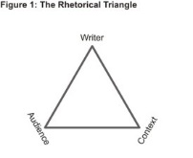

* A **rhetorical analysis** paper asks you to identify these three elements and determine how they are working together.

**Consider**: Which rhetorical strategies is the author employing to communicate his/her message to this specific audience? What is the effect of these strategies on the audience? And, most importantly, do you find these strategies convincing, given the author’s specific purpose and specific audience?

**Directions: Use your speech to complete ALL the questions below. Be sure that your answers are thorough and in complete sentences.**

**Orator’s Name: _______________________________________ “Title of Speech”:_______________________________**

**Date of the Speech: ____________________________________ Location of Speech:____________________________**

**Historical Context of the Speech**

1. **Research the historical context for this particular speech.**

**\*What are 3 important political/cultural events happening in the United States that would be relevant &**

**important to this speech?**

**\*What are 2 important political/cultural events happening around the World during the time of this speech?**

**_____________________________________________________________________________________________________________________________________________________________________________________________________________________________________________________________________________________________**

1. **What happened to cause the need for a speech such as this one? [Use your research to answer this.]**

**_____________________________________________________________________________________________________________________________________________________________________________________________________________________________________________________________________________________________**

1. **\*What is the purpose of this speech?**

**\*What is the goal the speaker/writer is trying to accomplish through this rhetorical address? [Knowing the historical context will help tremendously with understanding the speaker’s purpose.]**

**_____________________________________________________________________________________________________________________________________________________________________________________________________________________________________________________________________________________________**

**The Speech itself**

1. **What are 2 claims the speaker makes in this speech? (A claim is the “thesis” like statement that the speaker will try to prove by the end of the speech)**

**_________________________________________________________________________________________________________________________________________________________________________________________________________________________________________________________________________________**

1. **What evidence is given by the speaker to support each claim?**

**Evidence for Claim # 1 _________________________________________________________________________________________________________________________________________________________________________________________________________________________________________________________________________________**

**Evidence for Claim # 2 _________________________________________________________________________________________________________________________________________________________________________________________________________________________________________________________________________________**

1. **Name 3 rhetorical devices the speaker used effectively in this speech.**

**Then provide a quote as evidence of each rhetorical device**.

**________________________________________________________________________________________________________________________________________________________________________________________________________________________________________________________________________**

1. **Find 3 examples of logos the speaker used in the speech in order to be persuasive and achieve a specific goal. (significant facts, statistics, famous quotes, etc. )**

**_________________________________________________________________________________________________________________________________________________________________________________________________________________________________________________________________________________**

1. **Does the speaker effectively persuade the audience and achieve his/her purpose?**

**________________________________________________________________________________________________________________________________________________________________________________________________________________________________________________________________________**

**The Audience**

1. Who is the audience for this speech? ___________________________________________________________________________________
2. Determine the characteristics of the audience: What clues from the speech or historical context provide clues about who the audience is: Try to identify the audience’s: Age, sex, race, physical characteristics, habits, Economic or educational level, Religious or educational level, and ethnicity. **_________________________________________________________________________________________________________________________________________________________________________________________________________________________________________________________________________________**
3. What is the emotional response (pathos) the audience/reader is encouraged to have when hearing this particular speech? How can you tell? **_________________________________________________________________________________________________________________________________________________________________________________________________________________________________________________________________________________**
4. Find 2-3 examples/quotes in the speech where **pathos** is used to create an emotional response in the audience. **_________________________________________________________________________________________________________________________________________________________________________________________________________________________________________________________________________________**
5. Is the audience encouraged to examine or question the opposition’s motives? (Opposition means anyone who would have a differing opinion from the speaker.)

**_________________________________________________________________________________________________________________________________________________________________________________________________________________________________________________________________________________**

1. What needs, values, or beliefs does the audience of this speech seem to have? What clues indicate this? **_________________________________________________________________________________________________________________________________________________________________________________________________________________________________________________________________________________**

**The Speaker & Ethos**

1. **Who is the speaker? ____________________________________________________________________**
2. **What position/job does the speaker have? (You may need to research this.)**

**_________________________________________________________________________________________**

1. **What power or influence does this speaker have based on his/her position or job?**

**___________________________________________________________________________________**

1. **Explain how the speaker establishes his or her own credibility (ethos)?**

**___________________________________________________________________________________________**

1. **Provide a quote by identifying words and phrases the speaker uses to suggest that he/she is an expert on this topic?**

**______________________________________________________________________________________________________________________________________________________________________________________________**



**Steps 1-6 are due:**_________________________________________________________________

**You’re almost there! Finish it up by putting it all together…**

1. Create an infographic (like the one below) to represent the most important ideas and information from the speech in a visually attractive manner. You may use programs on your computer (you must print it **IN COLOR**) for this or you may illustrate this by hand. I highly recommend CANVA.

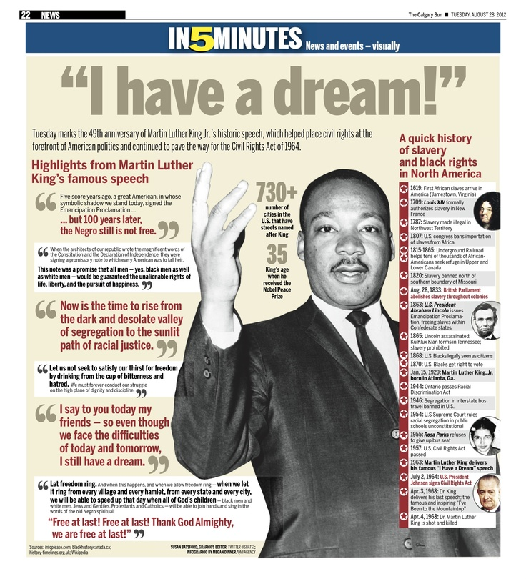

**How will I be evaluated?**

|  |  |  |  |  |  |
| --- | --- | --- | --- | --- | --- |
| **Criteria** | **5**  **Exceptional** | **4**  **Above Average** | **3**  **Proficient** | **2**  **Emerging** | **1**  **Not Evident** |
| **(X2)** Determine the meaning of words and phrases as they are used in a text; analyze how an author uses and refines the meaning of a key term or terms over the course of a text. (RI.4)   * Tone analysis component * The speech itself component * Infographic |  |  |  |  |  |
| **(X2)** Determine an author's point of view or purpose in a text in which the rhetoric is particularly effective, analyzing how style and content contribute to the power and/or persuasiveness of the text. (RI.6)   * Rhetorical analysis components combined * Infographic |  |  |  |  |  |
| **(X2)** Analyze foundational U.S. and/or British documents of historical and literary significance for their themes, purposes, and rhetorical features. (RI.9)   * Rhetorical analysis components combined * Infographic |  |  |  |  |  |
| (**X2)** Write arguments to support claims in an analysis of substantive topics or texts, using valid reasoning and relevant and sufficient evidence. (W.1)   * INFROGRAPHIC |  |  |  |  |  |
| **(X2)** Use digital tools and resources to produce, publish, and update individual or shared writing products in response to ongoing feedback, including new arguments or information. (W.4)   * Creation of infographic was neat, colorful, and creative in graphics |  |  |  |  |  |
| Demonstrate command of the conventions of standard English grammar and usage when writing or speaking; demonstrate proficiency within the 9-12 grammar continuum. (L.1) |  |  |  |  |  |
| Demonstrate command of the conventions of standard English capitalization, punctuation, and spelling when writing; demonstrate proficiency within the 9-12 conventions continuum. (L.2) |  |  |  |  |  |

**Final Grade:** __________/**60 points**