Name:__________________________________ Period:_____

Rhetoric: The Art of Persuasion

Rhetoric Definition:

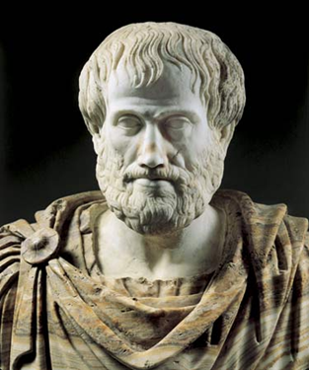

Technique # 1: ETHOS

1.

2.

3.

3 Rhetorical Techniques that help you convince your audience:

*Aristotle said there are ____________ techniques a speaker can use to ___________________ or ________________ the audience*

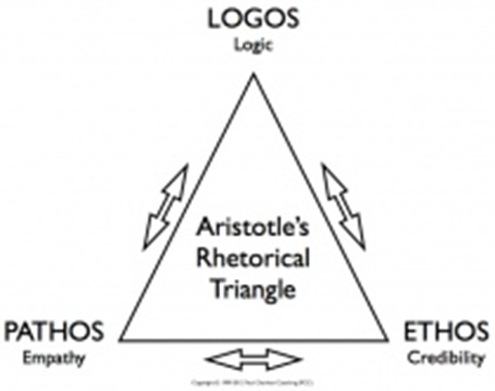

People who give speeches are called:

1.

2.

3.

Aristotle’s Explanation =

Technique # 2: LOGOS

1.

2.

Technique # 3: PATHOS

1.

2.

3.