Guided Notes: Introduction to Modernism
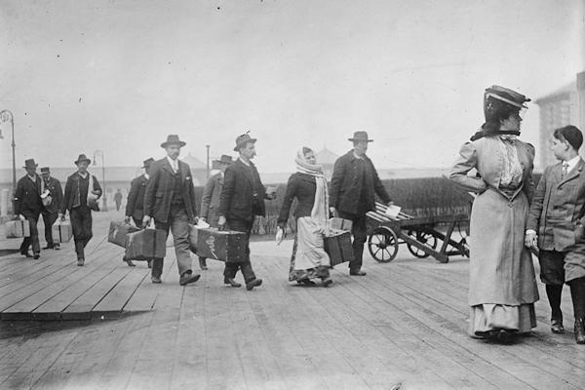
The American Dream:
- America as a _______________________________
-- a land of _______________, _____________, and _____________________________
- A Belief in __________________________________
- _________________ and _____________________
- Triumph of _________________________________
- Independence and __________________________

The Great War
__________________________ began in 1914 with the assassination of __________________________________________________________________________________
- The U.S. entered the war in _____________
- Nearly ______________________________________ lives were lost
- The ________________________________________________ ended the war in June 1919

_________________________ (1919):
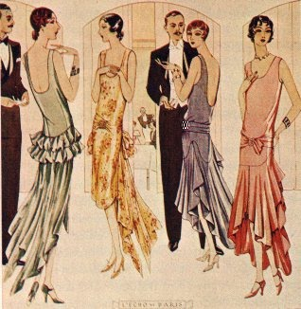
- The manufacture and sale of ________________ were prohibited by the ________________________________________________________
- Instead of encouraging traditional values, Prohibition brought…
  - _________________________________________________
  - ________________________ and Cocktails
  - _________________________________________________
  - Gangsters (Real OGs)
  - ________________________________________________
What happened in 1929?
- The ___________________________________________________
- The beginning of _________________________________________

The Great Depression
- Poverty Loss of Jobs Starvation
- Millions of Americans were _____________________, ______________________, and ____________________
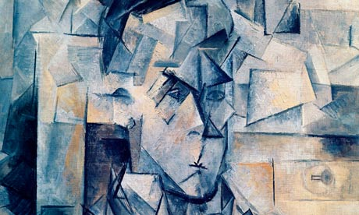
Characteristics of Modernism

- ___________________________ in style and form representing the ____________________________ of society
- _____________________________: the feeling of _________________________ resulting from the discovery that something is not as good as one believed it to be
- Rejection of ___________________________________________
- _____________________________________: Heroes who are ________________ and __________________________, but they show “________________________________” (endurance, honor, and courage)
- ________________________:
- Introduced by ___________________________
- Interested in the ________________________________ of the human mind
- Stream of ___________________________ writing

